* ***UV-C Sterilization***
* ***Use UV-C LEDs (e.g., 275nm wavelength) to kill bacteria, viruses, and mold inside the bin.***
* ***Add a scanner to***
* ***Arduino Code****: Write efficient code to handle sensor inputs and control the motors. Use libraries like* ***AccelStepper*** *for stepper motor control and* ***Servo*** *for servo motor control.*
* ***Error Handling****: Implement error handling for cases where waste cannot be identified or the system malfunctions. ( by addition of a miscellaneous box and by doing research we can come to solution for them also.*
* ***Calibration****: Allow for calibration of sensors to improve accuracy.*

### ***1. Residential Waste Management***

***Application****:*

* *Automated waste segregation in households, apartment complexes, or gated communities.*
* *Encourages residents to dispose of waste responsibly by automating the sorting process.*

***Improvements****:*

* ***User-Friendly Design****: Add a touchscreen interface or mobile app integration for easy operation.*
* ***Compact Size****: Design the system to fit in small spaces like kitchens or balconies.*
* ***Odor Control****: Integrate a small air purifier or deodorizer to handle wet waste odors.(bamboo)*
* ***IoT Integration****: Send notifications to residents when bins are full or need maintenance.*

### ***Potential for IoT Integration***

***Unique Factor****:  
Your project’s use of an Arduino Uno makes it easy to integrate IoT capabilities for advanced features.*

***How to Enhance****:*

* ***Real-Time Monitoring****: Add a Wi-Fi module to send data about waste levels and system status to a cloud platform or mobile app.*
* ***Notifications****: Send alerts to users or maintenance staff when bins are full or if there’s a system error.*
* ***Data Analytics****: Track waste segregation trends and provide insights for waste reduction or recycling.*

### ***2. Commercial and Office Spaces***

***Application****:*

* *Waste segregation in cafeterias, offices, and commercial buildings.*
* *Helps organizations comply with waste management regulations and reduce their environmental footprint.*

***Improvements****:*

* ***High-Capacity Bins****: Use larger bins to handle higher volumes of waste.*
* ***Advanced Sensors****: Add a* ***weight sensor*** *to monitor waste levels and optimize collection schedules.*
* ***Data Analytics****: Integrate IoT to track waste generation patterns and provide insights for waste reduction.( from this they can work on those waste and reduce the major cause and it can reduce taxation example- starbucks*
* ***Aesthetic Design****: Make the system visually appealing to fit into office environments.*

### ***3. Industrial Waste Management***

***Application****:*

* *Segregation of industrial waste, such as metal scraps, packaging materials, and organic waste.*
* *Useful in manufacturing units, warehouses, and factories.*

***Improvements****:*

* ***Heavy-Duty Components****: Use industrial-grade motors and sensors to handle heavy and bulky waste.*
* ***Conveyor Belt System****: Integrate a conveyor belt for continuous waste processing.*
* ***Hazardous Waste Detection****: Add sensors to detect hazardous materials (e.g., chemicals or flammable substances). Like in radioactivity labs and research sensors.*
* ***Durability****: Use rugged materials to withstand harsh industrial environments.*

### ***4. Public Spaces and Municipal Waste Management***

***Application****:*

* *Waste segregation in parks, streets, and public bins.*
* *Helps municipalities improve recycling rates and reduce landfill waste.*

***Improvements****:*

* ***Solar Power****: Use solar panels to power the system, making it energy-efficient and suitable for outdoor use.( electricity convertor )*
* ***Solar Charging****: Add a solar panel to charge the batteries, making the system eco-friendly and suitable for outdoor use.*
* ***Battery Monitoring****: Use a battery management system (BMS) to monitor battery health and provide low-battery alerts.*
* ***Energy-Efficient Mode****: Implement a sleep mode to conserve energy when the system is not in use.*
* ***Vandal-Proof Design****: Use durable materials and secure components to prevent tampering.*
* ***Large-Scale Sorting****: Design the system to handle large volumes of waste with multiple sorting categories.(in mining areas and coal factory and separating essential components)*
* ***Real-Time Monitoring****: Use IoT to send data to municipal authorities for efficient waste collection.(Add a Wi-Fi module to send data about waste levels and system status to a cloud platform or mobile app.)*

### ***5. Educational Institutions***

***Application****:*

* *Waste segregation in schools, colleges, and universities.*
* *Educates students about responsible waste disposal and recycling.*

***Improvements****:*

* ***Interactive Features****: Add an educational display or gamification to engage students.*
* ***Compact and Portable Design****: Make the system easy to move for use in different areas of the campus.*
* ***Composting Integration****: Add a composting unit for wet waste to promote sustainability.*
* ***Data Tracking****: Track waste segregation trends and use the data for environmental awareness programs.( it's like a display system used in offices which will provide daily report to the employs as it could be wallpaper of desktop)(Track waste segregation trends and provide insights for waste reduction or recycling.)*
* ***Agricultural waste find some points.***
* ***Recycling Awareness Campaigns: Use the system to promote recycling among travelers.***

### ***2. Gamification and User Engagement***

* ***Reward System: Integrate a points-based system where users earn rewards for proper waste disposal. For example, scanning a QR code after disposing of waste could earn them points redeemable for discounts or gifts.***
* ***Interactive Display: Add an LCD or LED screen to display fun messages, recycling facts, or a leaderboard for users who segregate waste correctly.***
* ***Sound Effects: Use the buzzer to play positive sounds or messages when waste is disposed of correctly.***

***to make your waste segregation project unique, you need to focus on innovation, user experience, sustainability, and practicality. Below are the key factors that can set your project apart from existing solutions:***

### ***1. Smart Technology Integration***

* ***IoT Connectivity: Add Wi-Fi or Bluetooth modules (e.g., ESP8266, ESP32) to enable real-time monitoring, remote control, and data analytics.***
* ***AI/ML-Based Waste Classification: Use a camera and machine learning algorithms to classify waste more accurately (e.g., plastic, paper, metal, organic).***
* ***Mobile App Integration: Develop a companion app to provide users with waste segregation statistics, notifications, and rewards.***

### ***2. User-Centric Design***

* ***Gamification: Introduce a reward system where users earn points for proper waste disposal, redeemable for discounts or gifts.***
* ***Interactive Interface: Use an LCD or touchscreen display to provide instructions, recycling tips, or fun facts.***
* ***Voice Feedback: Add a voice module to guide users through the waste disposal process (e.g., "Please dispose of metallic waste here").***

### ***3. Sustainability Features***

* ***Solar-Powered Operation: Use solar panels to make the system energy-efficient and suitable for outdoor use.***
* ***Composting Unit: Integrate a small composting chamber for wet waste, turning it into compost over time.***
* ***Recycled Materials: Build the system using recycled or eco-friendly materials to emphasize sustainability.***

### ***4. Advanced Waste Detection***

* ***Multi-Sensor Fusion: Combine data from multiple sensors (e.g., moisture, metal detection, color sensing) to improve waste classification accuracy.***
* ***Camera-Based Classification: Use a camera and image recognition to identify different types of waste.***
* ***Weight Sensors: Add load cells to measure the weight of waste in each bin, helping optimize waste collection schedules.***

### ***5. Automation and Efficiency***

* ***Conveyor Belt System: Automate waste movement using a conveyor belt for faster and more efficient sorting.***
* ***Automatic Lid: Use a servo motor to open and close the lid when waste is detected, reducing contact with the bin.***
* ***Self-Cleaning Mechanism: Add a cleaning feature (e.g., water spray or UV sterilization) to maintain hygiene.***

### ***6. Customizability***

* ***Multi-Language Support: Add support for multiple languages on the display or voice feedback for diverse user groups.***

### ***10. Aesthetic and Ergonomic Design***

* ***Modern Look: Use sleek, modern materials and colors to make the system visually appealing.***
* ***Ergonomic Placement: Design the system for easy access and use, especially in public spaces or offices.***

### ***11. Low-Cost and Scalable Solutions***

* ***Affordable Components: Use low-cost sensors and materials without compromising functionality.***
* ***Scalable DeAdjustable Waste Categories: Allow users to customize waste categories (e.g., adding a bin for e-waste or glass).***
* ***Modular Design: Make the system modular so it can be easily expanded or adapted for different environments (e.g., homes, offices, public spaces).***

### ***7. Educational and Awareness Features***

* ***Environmental Impact Tracker: Display how much waste has been segregated and its environmental impact (e.g., trees saved, CO2 reduced).***
* ***Recycling Tips: Show users how to recycle or reduce waste through the display or app.***
* ***QR Code Scanner: Add a QR code scanner to identify and classify specific types of waste (e.g., packaging materials).***

### ***8. Safety and Hygiene***

* ***UV Sterilization: Use UV light to sterilize waste or the bin interior, especially useful for wet or medical waste.***
* ***Odor Control: Integrate a small fan or deodorizer to minimize odors from wet waste.***
* ***Hazardous Waste Detection: Add sensors to detect hazardous materials (e.g., chemicals or flammable substances).***

### ***9. Portability and Versatility***

* ***Portable Design: Make the system lightweight and easy to transport for use in remote areas, events, or disaster relief camps.***
* ***sign: Ensure the system can be easily scaled up for larger applications (e.g., municipal waste management).***

### ***12. Unique Use Cases***

* ***Waste-to-Art Integration: Compact waste into blocks or shapes that can be used for art or construction projects.***
* ***Event Waste Management: Design the system for temporary use at festivals, concerts, or sports events.***
* ***Educational Tool: Use the system in schools or colleges to teach students about waste segregation and recycling.***

### ***13. Marketing and Branding***

* ***Custom Branding: Add your project’s logo or name to the system for recognition.***
* ***Social Media Integration: Allow users to share their waste segregation achievements on social media, promoting awareness.***

### ***14. Testing and Feedback Mechanism***

* ***User Feedback: Add a button or interface for users to provide feedback on the system’s performance.***
* ***Self-Diagnosis: Implement a self-diagnosis feature to detect and report system errors or sensor malfunctions.***

### ***15. Real-World Impact***

* ***Community Engagement: Partner with local communities or organizations to deploy the system and promote waste segregation.***
* ***Data-Driven Insights: Use the collected data to provide insights to municipalities or businesses for better waste management strategies.***

***Benefits or plus point about our project-***

### ***Compact and Lightweight Design***

***Unique Factor:  
Your project’s use of lightweight components like the 9g servo motor and small sensors makes it compact and easy to handle.***

***How to Enhance:***

* ***Portable Version: Design a foldable or collapsible version for easy transportation.***
* ***Wall-Mounted Design: Create a wall-mounted version for use in small spaces like kitchens or offices.***
* ***Aesthetic Appeal: Use sleek, modern materials and colors to make the system visually appealing.***

### ***Challenges***

#### ***1. Sensor Accuracy and Reliability***

* ***Challenge: Sensors like the moisture sensor, IR sensor, and proximity sensor may not always provide accurate readings due to environmental factors (e.g., dust, humidity, or interference).***
* ***Solution:***
  + ***Use sensor fusion (combining data from multiple sensors) to improve accuracy.***
  + ***Regularly calibrate sensors to maintain reliability.***
  + ***Use higher-quality or industrial-grade sensors for better performance.***

This is a **critical challenge** in waste segregation systems, especially when dealing with mixed waste. The presence of moisture from wet waste (e.g., food scraps) can affect the detection of other types of waste (e.g., dry or metallic waste). Here’s how you can address this issue:

### **1. Problem Analysis**

* **Humidity from Wet Waste**: Wet waste can create a humid environment inside the bin, making it difficult to distinguish between wet and dry waste.
* **Mixed Waste**: When waste is mixed, the moisture from wet waste can spread to dry waste, making it appear "wet."
* **Sensor Limitations**: Moisture sensors may not accurately detect wet waste if the entire bin becomes humid.

### **2. Solutions to Improve Detection**

#### **a. Physical Separation of Waste**

* **Separate Compartments**: Design the system with separate compartments for wet, dry, and metallic waste. Use a **mechanical flap or gate** controlled by the servo motor to direct waste into the correct compartment.
* **Pre-Sorting**: Encourage users to pre-sort waste before disposal (e.g., separate wet and dry waste at the source).

#### **b. Advanced Sensor Fusion**

* **Combine Multiple Sensors**: Use a combination of sensors to improve detection accuracy:
  + **Moisture Sensor**: Detect wet waste.(30rupees)
  + **Metal Detection Sensor**: Identify metallic waste(60rupees).
  + **Color Sensor or Camera**: Classify dry waste based on color or material.(200 rupees)
  + **Weight Sensor**: Measure the weight of waste to assist in classification.(200 rupees
  + **ULTRA SONIC SENSOR-**
  + Object detection and distance measure
  + Detect small object over small distance
  + Independent from the object surface and texture
  + Great for solid material :metals, glass, wood plastics, paper etc
  + Rolled goods: tissue,textile, ….
  + Bulk goods:sugar, flour, potatoes,....

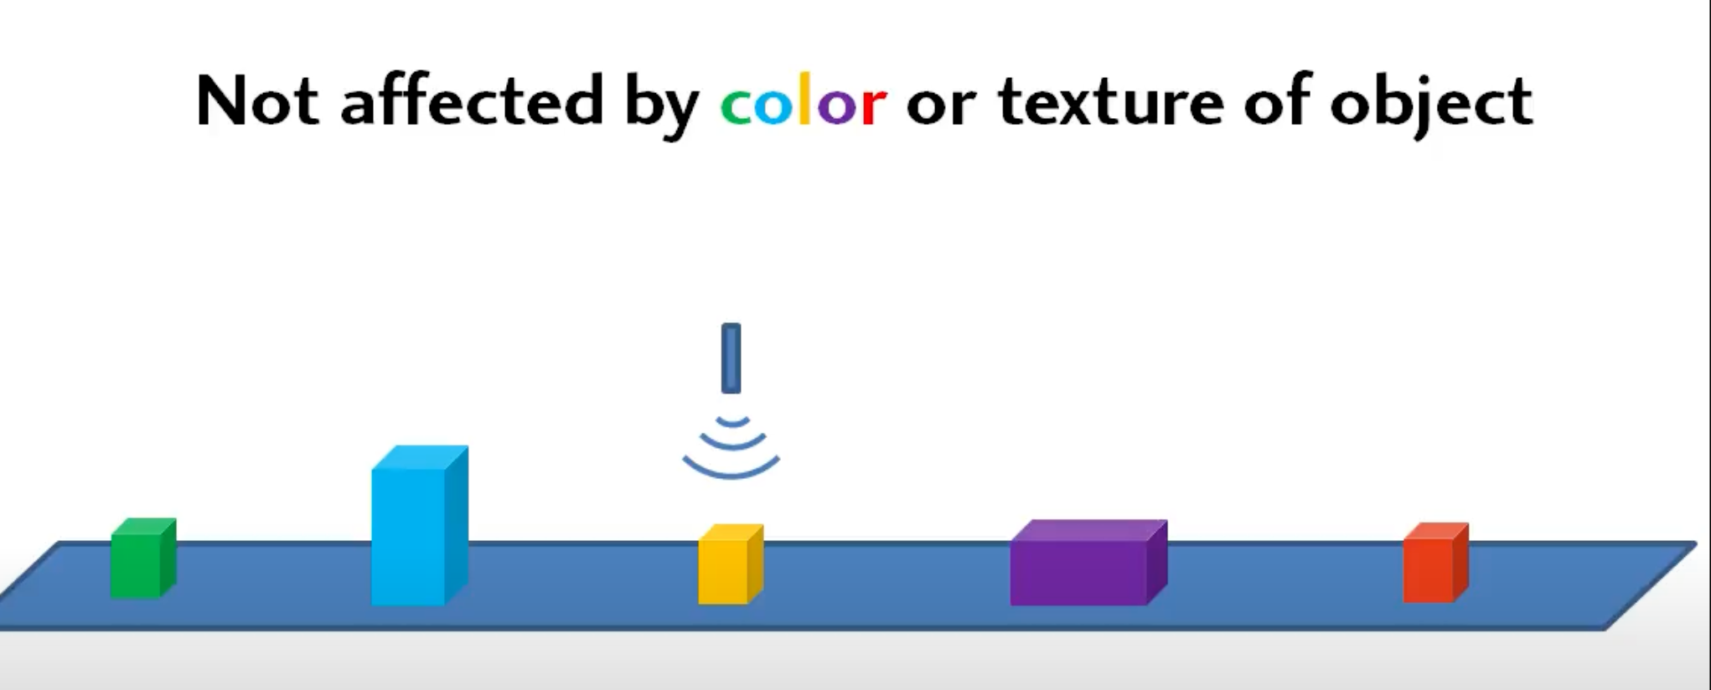

* + 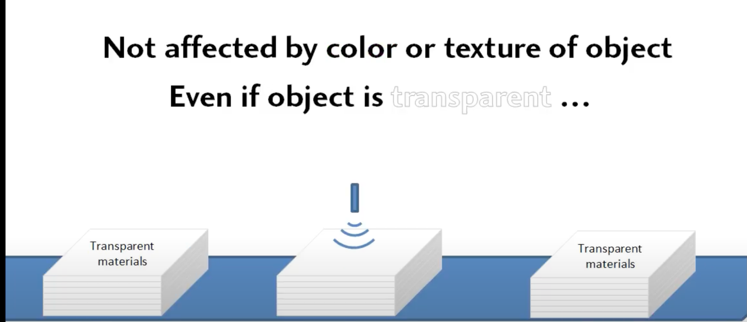
  + Liquids:Water,OIl, juices,...
* **AI/ML Algorithms**: Train a machine learning model to analyze data from multiple sensors and classify waste more accurately, even in mixed conditions.

#### **c. Humidity-Resistant Sensors**

* **Use Robust Sensors**: Choose sensors that are less affected by humidity or can operate in humid environments.

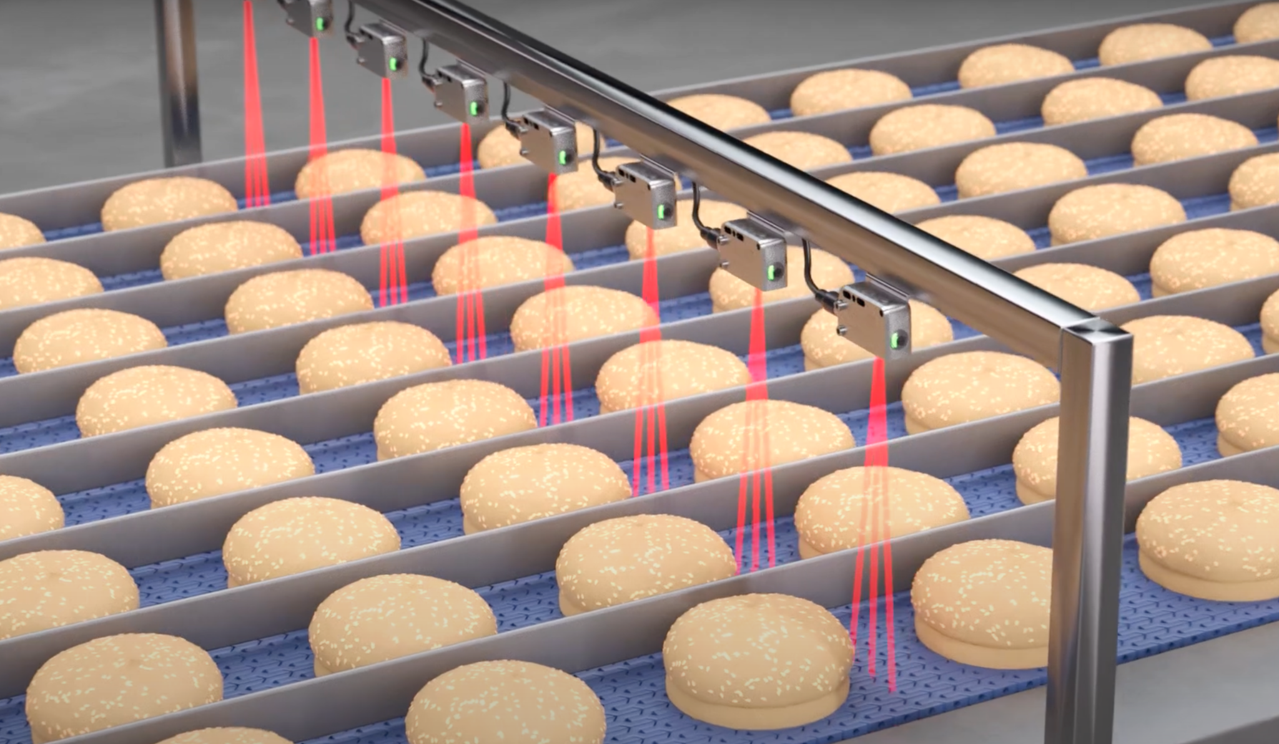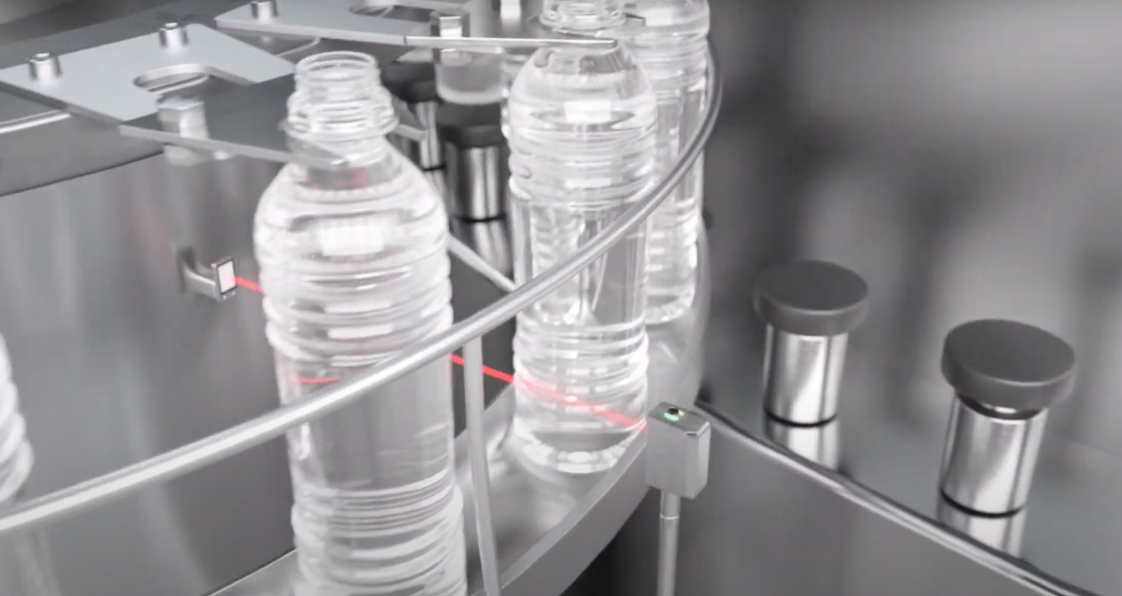

* **Protective Enclosures**: Place sensors in protective enclosures to shield them from direct contact with waste or moisture.

#### **d. Real-Time Waste Analysis**

* **In-Line Detection**: Use a **conveyor belt system** to move waste past the sensors one piece at a time, reducing the chance of mixed waste interfering with detection.
* **Airflow System**: Add a small fan or airflow system to dry the surface of waste before it reaches the sensors.

#### **e. User Feedback and Correction**

* **Manual Override**: Allow users to manually correct misclassified waste (e.g., via a touchscreen or mobile app).

***c*Feedback Mechanism**: Use the buzzer or LED indicators to alert users if waste is misclassified and needs to be re-disposed.

### **3. Design Improvements**

#### **a. Modular Bin Design**

* **Separate Bins**: Use separate bins for wet, dry, and metallic waste, with sensors placed at the entry point of each bin.
* **Rotating Platform**: Use a rotating platform to direct waste into the correct bin based on sensor input.

#### **b. Pre-Processing System**

* **Waste Separation Mechanism**: Add a mechanism to separate waste into individual pieces before detection (e.g., a rotating drum or vibrating sieve).
* **Drying Mechanism**: Use a small heating element or airflow system to dry waste before it reaches the sensors.

#### **c. Multi-Stage Detection**

* **Stage 1**: Detect metallic waste using a metal detection sensor.
* **Stage 2**: Detect wet waste using a moisture sensor.
* **Stage 3**: Classify remaining waste as dry by default.

### **4. Practical Example**

Here’s how the system could work in practice:

1. **Waste Entry**: Waste is placed on a conveyor belt or rotating platform.
2. **Metal Detection**: A metal detection sensor identifies and removes metallic waste.
3. **Moisture Detection**: A moisture sensor detects wet waste and directs it to the wet waste bin.
4. **Dry Waste Classification**: Remaining waste is classified as dry and directed to the dry waste bin.
5. **User Feedback**: If waste is misclassified, the system alerts the user to correct the error.

### **5. Testing and Calibration**

* **Test with Real Waste**: Use real-world waste samples to test and calibrate the sensors.
* **Adjust Sensitivity**: Fine-tune sensor sensitivity to account for humidity and mixed waste conditions.
* **Iterate**: Continuously improve the system based on testing results.

### **6. Advanced Solutions**

If you want to take the project to the next level:

* **AI-Powered Waste Recognition**: Use a camera and machine learning to visually classify waste, even in mixed or humid conditions.
* **Robotic Arm**: Integrate a robotic arm to physically separate waste before detection.
* **Composting Integration**: Direct wet waste to a composting unit, reducing the need for precise classification.

***MARKET COMPETITORS***

***When developing a waste segregation project, it’s important to understand the market landscape and identify competitors. This will help you differentiate your project and identify opportunities for innovation. Below is an analysis of existing competitors and solutions in the waste segregation and smart waste management market:***

### ***1. Smart Waste Bins***

#### ***Competitors:***

* ***Bin-E (Poland): A smart waste bin that uses AI and sensors to automatically sort waste into categories like plastic, glass, and paper.***
* ***TetraBIN (Australia): An interactive waste bin that gamifies waste disposal using LED displays.***
* ***Ecube Labs (South Korea): Provides solar-powered smart waste bins with fill-level monitoring and compaction features.***

#### ***How Your Project Can Differentiate:***

* ***Focus on low-cost, modular designs that are accessible to households and small businesses.***
* ***Add educational features like gamification or real-time feedback to encourage user engagement.***

### ***2. Waste Sorting Robots***

#### ***Competitors:***

* ***AMP Robotics (USA): Uses AI-powered robots to sort recyclable materials from waste streams.***
* ***ZenRobotics (Finland): Develops robotic waste sorting systems for industrial and municipal applications.***
* ***Sadako Technologies (Spain): Specializes in AI-based waste sorting robots for recycling plants.***

#### ***How Your Project Can Differentiate:***

* ***Target small-scale applications like homes, schools, or offices, where robotic solutions are not feasible.***
* ***Focus on affordability and ease of use for non-industrial users.***

### ***3. IoT-Enabled Waste Management Systems***

#### ***Competitors:***

* ***Enevo (Finland): Provides IoT-based waste monitoring solutions for optimizing waste collection routes.***
* ***Bigbelly (USA): Offers solar-powered smart waste bins with compaction and real-time monitoring.***
* ***WasteHero (Denmark): A smart waste management platform that uses sensors and data analytics to optimize waste collection.***

#### ***How Your Project Can Differentiate:***

* ***Integrate waste segregation with IoT capabilities, offering both sorting and monitoring in one system.***
* ***Focus on community-level solutions rather than large-scale municipal applications.***

### ***4. Home Waste Segregation Devices***

#### ***Competitors:***

* ***TrashBot (USA): A smart trash can that uses AI to sort waste into recyclables and landfill.***
* ***Sepura (Canada): A home waste disposal system that separates organic waste from solids.***
* ***GeniCan (USA): A device that scans barcodes on waste items and adds them to a shopping list or recycling guide.***

#### ***How Your Project Can Differentiate:***

* ***Offer a low-cost, DIY solution that can be built and customized by users.***
* ***Focus on educational and gamification features to promote waste segregation awareness.***

### ***5. Industrial Waste Sorting Systems***

#### ***Competitors:***

* ***Tomra Sorting Solutions (Norway): Provides sensor-based sorting systems for recycling and waste management.***
* ***Bühler Group (Switzerland): Offers optical sorting solutions for waste and recycling.***
* ***Pellenc ST (France): Specializes in optical sorting technologies for waste and recycling.***

#### ***How Your Project Can Differentiate:***

* ***Focus on small-scale, affordable solutions for households, schools, or small businesses.***
* ***Emphasize user-friendly design and ease of maintenance.***

### ***6. Educational and Community-Based Solutions***

#### ***Competitors:***

* ***Recyclebank (USA): A platform that rewards users for recycling and sustainable practices.***
* ***Rubicon Global (USA): A waste management platform that connects businesses with waste haulers and recyclers.***
* ***Litterati (USA): An app that encourages users to track and reduce litter in their communities.***

#### ***How Your Project Can Differentiate:***

* ***Combine hardware (waste segregation system) with software (educational platform) to create a holistic solution.***
* ***Focus on community engagement and local impact.***

### ***7. Key Differentiators for Your Project***

***To stand out in the market, consider the following unique features for your project:***

1. ***Low-Cost and DIY: Offer an affordable, build-it-yourself solution that can be easily replicated and customized.***
2. ***Educational Focus: Include features like gamification, real-time feedback, and recycling tips to educate users.***
3. ***Modular Design: Make the system modular and scalable for different applications (e.g., homes, schools, offices).***
4. ***IoT Integration: Add IoT capabilities for real-time monitoring and data analytics.***
5. ***Sustainability: Use eco-friendly materials and solar power to emphasize environmental responsibility.***
6. ***Community Impact: Focus on small-scale, community-level solutions that promote local engagement and awareness.***

### ***8. Market Opportunities***

***Here are some untapped opportunities in the waste segregation market:***

* ***Household Solutions: Affordable, user-friendly systems for homes.***
* ***Educational Institutions: Waste segregation systems for schools and colleges to teach students about recycling.***
* ***Small Businesses: Compact systems for cafes, offices, and small businesses.***
* ***Developing Countries: Low-cost solutions for regions with limited waste management infrastructure.***
* ***Events and Public Spaces: Portable systems for festivals, parks, and public areas.***

### ***9. Competitive Analysis Table***

| ***Competitor*** | ***Key Features*** | ***Target Market*** | ***Your Differentiator*** |
| --- | --- | --- | --- |
| ***Bin-E*** | ***AI-based sorting, multiple waste categories*** | ***Commercial, Municipal*** | ***Low-cost, modular, educational focus*** |
| ***AMP Robotics*** | ***AI-powered robotic sorting*** | ***Industrial*** | ***Small-scale, affordable, user-friendly*** |
| ***Enevo*** | ***IoT-based waste monitoring*** | ***Municipal, Commercial*** | ***Combines segregation with IoT and analytics*** |
| ***TrashBot*** | ***AI-based home waste sorting*** | ***Households*** | ***DIY, gamification, community engagement*** |
| ***Recyclebank*** | ***Rewards for recycling*** | ***Community, Households*** | ***Hardware + software for waste segregation*** |

### ***Market Segmentation***

| ***Market Segment*** | ***Key Needs*** | ***Your Solution*** |
| --- | --- | --- |
| ***Households*** | ***Affordable, easy-to-use waste segregation*** | ***Compact, low-cost system with educational features*** |
| ***Educational Institutions*** | ***Promote environmental awareness*** | ***Gamification, data analytics, portable design*** |
| ***Small Businesses*** | ***Efficient waste management, compliance*** | ***IoT integration, odor control, compact design*** |
| ***Public Spaces*** | ***Cleanliness, public awareness*** | ***Solar-powered, weather-resistant, real-time monitoring*** |
| ***Events and Festivals*** | ***Temporary, high-capacity waste management*** | ***Portable, high-speed sorting, gamification*** |
| ***Developing Countries*** | ***Low-cost, sustainable waste solutions*** | ***Solar-powered, durable, community-focused*** |

### ***Unique Selling Proposition (USP)***

***Your project stands out because:***

1. ***Affordability: It’s a low-cost solution compared to industrial systems.***
2. ***Modularity: It can be customized for different applications (homes, schools, businesses, etc.).***
3. ***Educational Value: It promotes awareness and encourages responsible waste disposal.***
4. ***Sustainability: It uses eco-friendly materials and solar power.***
5. ***Innovation: It combines automation, IoT, and gamification for a unique user experience.***

### ***Next Steps***

1. ***Prototype Testing: Test the system with real users in your target markets (e.g., households, schools).***
2. ***Feedback and Iteration: Gather feedback and improve the design based on user needs.***
3. ***Pilot Projects: Launch pilot projects in specific markets to demonstrate the system’s effectiveness.***
4. ***Partnerships: Collaborate with local governments, NGOs, or businesses to scale the solution.***

### ***Unique Selling Proposition (USP)***

***Your project stands out because:***

1. ***Affordability: It’s a low-cost solution compared to industrial systems.***
2. ***Modularity: It can be customized for different applications (homes, schools, businesses, etc.).***
3. ***Educational Value: It promotes awareness and encourages responsible waste disposal.***
4. ***Sustainability: It uses eco-friendly materials and solar power.***
5. ***Innovation: It combines automation, IoT, and gamification for a unique user experience.***
6. ***6. Due to sanitization and for maintaining hygiene and stopping spread of diseases, odor,***

### ***Next Steps***

1. ***Prototype Testing: Test the system with real users in your target markets (e.g., households, schools).***
2. ***Feedback and Iteration: Gather feedback and improve the design based on user needs.***
3. ***Pilot Projects: Launch pilot projects in specific markets to demonstrate the system’s effectiveness.***
4. ***Partnerships: Collaborate with local governments, NGOs, or businesses to scale the solution.***

### ***Problems Solved by Your Project***

#### ***1. Improper Waste Segregation***

* ***Problem: Many households, businesses, and communities do not segregate waste properly, leading to inefficient recycling and increased landfill waste.***
* ***Solution: Your project automates waste segregation into categories like metallic, wet, and dry waste, ensuring proper disposal and recycling.***

#### ***2. Lack of Awareness***

* ***Problem: People often lack awareness about the importance of waste segregation and recycling.***
* ***Solution: Your system can include educational features like real-time feedback, gamification, and recycling tips to educate users.***

#### ***3. Inefficient Waste Management***

* ***Problem: Manual waste segregation is time-consuming and prone to errors.***
* ***Solution: Your project automates the process, saving time and improving accuracy.***

#### ***4. High Costs of Industrial Solutions***

* ***Problem: Industrial waste segregation systems are expensive and not feasible for small-scale applications.***
* ***Solution: Your project offers a low-cost, modular solution that can be used in homes, schools, and small businesses.***

#### ***5. Environmental Impact***

* ***Problem: Improper waste disposal leads to environmental pollution and resource wastage.***
* ***Solution: By ensuring proper waste segregation, your project promotes recycling and reduces landfill waste, contributing to a cleaner environment.***

#### ***6. Hygiene and Odor Issues***

* ***Problem: Mixed waste, especially wet waste, can cause odors and hygiene issues.***
* ***Solution: Your system separates wet waste and can include features like odor control or UV sterilization to maintain hygiene.***

### ***Target Markets***

#### ***1. Households***

* ***Why: Households generate a significant amount of waste, and many lack proper segregation systems.***
* ***Value Proposition: An affordable, easy-to-use system that automates waste segregation and promotes recycling.***
* ***Features:***
  + ***Compact design for kitchens or balconies.***
  + ***Educational features for families.***
  + ***Low-cost and DIY options.***

#### ***2. Educational Institutions***

* ***Why: Schools and colleges are ideal for promoting environmental awareness and responsible waste disposal.***
* ***Value Proposition: A system that educates students about waste segregation while managing campus waste efficiently.***
* ***Features:***
  + ***Gamification to engage students.***
  + ***Data analytics to track waste reduction efforts.***
  + ***Portable and modular design for different campus areas.***

#### ***3. Small Businesses***

* ***Why: Cafes, offices, and small businesses generate waste that often goes unsegregated.***
* ***Value Proposition: A cost-effective solution to manage waste and comply with environmental regulations.***
* ***Features:***
  + ***Compact and easy-to-maintain design.***
  + ***IoT integration for waste monitoring.***
  + ***Odor control for food-related businesses.***

#### ***4. Public Spaces***

* ***Why: Parks, streets, and public bins often lack proper waste segregation systems.***
* ***Value Proposition: A portable, solar-powered system for efficient waste management in public areas.***
* ***Features:***
  + ***Weather-resistant design.***
  + ***Real-time monitoring for timely waste collection.***
  + ***Educational displays to promote public awareness.***

#### ***5. Events and Festivals***

* ***Why: Large gatherings generate massive amounts of mixed waste.***
* ***Value Proposition: A temporary, high-capacity waste segregation system for events.***
* ***Features:***
  + ***Portable and easy-to-set-up design.***
  + ***High-speed sorting for large volumes.***
  + ***Gamification to encourage attendees to segregate waste.***

#### ***6. Developing Countries***

* ***Why: Many developing regions lack proper waste management infrastructure.***
* ***Value Proposition: A low-cost, sustainable solution to improve waste segregation and recycling.***
* ***Features:***
  + ***Solar-powered operation for areas with limited electricity.***
  + ***Durable and easy-to-maintain design.***
  + ***Community engagement features.***

### ***Minimum Cost Breakdown in INR***

| ***Component*** | ***Quantity*** | ***Unit Cost (INR)*** | ***Total Cost (INR)*** |
| --- | --- | --- | --- |
| ***Arduino Uno SMD*** | ***1*** | ***₹500*** | ***₹500*** |
| ***9g Servo Motor*** | ***1*** | ***₹150*** | ***₹150*** |
| ***Stepper Motor*** | ***1*** | ***₹400*** | ***₹400*** |
| ***Stepper Motor Driver*** | ***1*** | ***₹200*** | ***₹200*** |
| ***Shaft Adaptor*** | ***1*** | ***₹100*** | ***₹100*** |
| ***Raindrop Moisture Sensor*** | ***1*** | ***₹100*** | ***₹100*** |
| ***IR Sensor*** | ***1*** | ***₹50*** | ***₹50*** |
| ***Proximity Sensor*** | ***1*** | ***₹150*** | ***₹150*** |
| ***USB Cable*** | ***1*** | ***₹50*** | ***₹50*** |
| ***Nuts and Bolts (3x20mm)*** | ***4*** | ***₹5*** | ***₹20*** |
| ***Nuts and Bolts (3x12mm)*** | ***6*** | ***₹5*** | ***₹30*** |
| ***F-F Jumpers*** | ***10*** | ***₹2*** | ***₹20*** |
| ***M-F Jumpers*** | ***3*** | ***₹5*** | ***₹15*** |
| ***18650 Li-ion Battery*** | ***2*** | ***₹200*** | ***₹400*** |
| ***2S 18650 Battery Holder*** | ***1*** | ***₹50*** | ***₹50*** |
| ***12V Male Jack*** | ***1*** | ***₹30*** | ***₹30*** |
| ***Big Buzzer*** | ***1*** | ***₹50*** | ***₹50*** |
| ***LCD Screen (16x2)*** | ***1*** | ***₹200*** | ***₹200*** |
| ***ESP8266 Wi-Fi Module*** | ***1*** | ***₹200*** | ***₹200*** |
| ***Solar Panel (Optional)*** | ***1*** | ***₹300*** | ***₹300*** |
| ***Acrylic/Plywood Frame*** | ***1*** | ***₹200*** | ***₹200*** |
| ***Total*** |  |  | ***₹3,265*** |

### ***Key Notes:***

1. ***Prices: These are minimum estimates based on affordable options available in India. Prices may vary slightly depending on the supplier and location.***
2. ***Optional Solar Panel: If you exclude the solar panel, the total cost reduces to ₹3,265.***
3. ***DIY Savings: If you already have some components (e.g., USB cable, nuts, bolts), the cost will be even lower.***
4. ***Local Markets: Buying from local electronics markets (e.g., SP Road in Bangalore, Lajpat Rai Market in Delhi) can further reduce costs.***

### ***Cost-Saving Tips:***

1. ***Reuse Components: Use recycled materials for the frame or repurpose old electronics.***
2. ***Bulk Purchases: If you’re building multiple units, buying in bulk can reduce costs.***
3. ***Negotiate: In local markets, you can often negotiate for better prices***

***Handling bulk waste is a common challenge in waste segregation systems. If waste is deposited in large quantities or mixed together, it can overwhelm the sensors and sorting mechanism. Here’s how you can design BinWise to handle bulk waste effectively:***

### ***1. Pre-Sorting Mechanism***

* ***Conveyor Belt System: Use a small conveyor belt to move waste one piece at a time past the sensors. This ensures that waste is processed individually, improving accuracy.***
* ***Vibrating Sieve: Add a vibrating sieve or rotating drum to separate large chunks of waste into smaller, manageable pieces before they reach the sensors.***

### ***2. Multi-Stage Sorting***

* ***Stage 1: Metal Detection: Use a metal detection sensor to remove metallic waste first. This reduces the load on other sensors.***
* ***Stage 2: Wet Waste Detection: Use a moisture sensor to identify and separate wet waste.***
* ***Stage 3: Dry Waste Classification: The remaining waste is classified as dry by default.***

### ***3. Bulk Waste Handling Features***

* ***Larger Bins: Use larger bins or containers to accommodate bulk waste.***
* ***Compaction System: Add a compactor to reduce the volume of waste, especially for dry and metallic waste.***
* ***Overflow Detection: Use ultrasonic sensors or weight sensors to detect when bins are full and alert users to empty them.***

### ***4. Advanced Sensor Fusion***

* ***AI/ML Algorithms: Train a machine learning model to analyze data from multiple sensors and classify waste more accurately, even in bulk or mixed conditions.***
* ***Camera-Based Sorting: Use a camera and image recognition to identify and sort waste more effectively.***

### ***5. User Feedback and Manual Override***

* ***Manual Sorting Option: Allow users to manually correct misclassified waste (e.g., via a touchscreen or mobile app).***
* ***Feedback Mechanism: Use the buzzer or LED indicators to alert users if waste is misclassified or if the system is overloaded.***

### ***6. Design Improvements***

* ***Rotating Platform: Use a rotating platform with separate compartments for each waste type. The platform can rotate to direct waste into the correct bin.***
* ***Modular Design: Design the system to be modular, so additional bins or sorting mechanisms can be added for high-volume applications.***

### ***7. Testing and Calibration***

* ***Test with Real Waste: Use real-world waste samples to test and calibrate the system for bulk waste handling.***
* ***Iterate: Continuously improve the system based on testing results.***